Week 3 Worklog Problem Identification & Requirement Analysis

Complete this worksheet as a team during or after the Week 3 workshop. Add more rows if needed.
Group | Forecasting 4 | Workshop | Thursday 3:30 – 5:30pm
Project title | AI-Powered Energy Prediction: Forecasting Model Development | Date | 22/08/2026
Client | ARC Research Hub for Integrated Energy Storage Solutions | Members present | Vidhi, Yaqiao, Marwa, Bhumika

  - Activity 1 Selecting the right methodology
Choose Waterfall, Agile or Hybrid for your project scenario and justify it against your requirements, timeline and team. Naming a methodology is not the task; defending the fit is.

Project | Forecasting Model Development: AI-Powered Energy Prediction
Requirements | - Develop a prototype platform with at least 2 types of ML/DL models. Must include model comparison, feature engineering, and interpretability analysis.  - The project follows a fixed 6-phase structure defined by Canvas (Phase 1-6).  - Need to respond to weekly tutor feedback and iterate on model improvements.
Timeline | 12 weeks total.  Phase 2 (Week 3-4): Feature Engineering & Baseline Modelling.  Phase 3(Week 5-7): Sequence Modelling & Tuning.  Incremental deliverables required each week.
Team size & skills | 4-person team with foundational Python/data science skills. Members have complementary strengths: some stronger in ML theory, others in coding and documentation.  We also have basic project management capabilities from previous coursework.
Methodology chosen | Agile (Scrum-based)
Why it fits | We chose Agile because it gives us clear, time-boxed weekly goals that keep us accountable and prevent procrastination. The weekly Worklog submissions fit naturally into Agile’s sprint-based rhythm, each week functions as a mini-sprint with defined deliverables.  Agile’s emphasis on short iteration cycles and regular feedback means we can quickly adjust our approach based on model performance or tutor feedback, which is essential for ML projects where experimentation is part of the process.  Additionally, the daily stand-up practice (which we can adapt to our workshop schedule) ensures everyone is aligned on what they’re doing and what’s blocking them, reducing the risk of miscommunication.  This structure works well for our team because we know exactly what needs to be done each week, no ambiguity means less chance of procrastination.
Rejected alternative & why not | Waterfall: Too rigid and linear. In ML projects, we often discover data issues or model limitations mid-way that require going back to earlier steps. Waterfall doesn’t support this well and would penalize us for exploring new approaches. Also, its “big delivery at the end” structure is a procrastination risk for our team.  Hybrid: While it offers some flexibility, it adds unnecessary complexity for a 12-week student project. Maintaining two sets of processes (Waterfall milestones + Agile sprints) creates overhead that our small team doesn’t need. Pure Agile gives us the structure we need without the extra coordination burden, and it aligns perfectly with our weekly submission cadence.

  - Activity 2 Project planning exercise
Build a high-level plan using the methodology chosen above. Phases and milestones must be consistent with that choice - fixed sequential phases suit Waterfall, iteration goals suit Agile.

Key phase | Milestone | Deliverable | Expected start | Expected end
Sprint 1: Project Setup & Data Preparation | Datasets confirmed and ready for analysis | GitHub repo created;  3 public datasets confirmed;  Cleaned datasets ready for EDA | Week 1 | Week 3 (completed)
Sprint 2: Feature Engineering & Baseline Modelling | Baseline model trained and evaluated | Feature engineering pipeline;  XGBoost baseline model;  MAE/RMSE/MAPE results | Week 3 | Week 5
Sprint 3: Sequence Modelling & Tuning | LSTM model trained and tuned | Tuned LSTM model;  Model comparison report;  Residual analysis | Week 5 | Week 8
Sprint 4: Explainability & Interpretability | Interpretability analysis complete | SHAP/LIME feature importance plots;  Temporal attribution summary;  Insights report | Week 8 | Week 10
Sprint 5: Documentation & Presentation Prep | Final report and slides drafted | Complete project documentation;  Presentation slides with key visualisations | Week 10 | Week 11
Sprint 6: Final Delivery & Presentation | Project delivered | Final presentation and demo;  Final report;  Codebase submitted | Week 11 | Week 12

Critical Path
List every task, its predecessors and its duration, then draw the network diagram in Draw.io. The critical path is the longest chain of dependent tasks - any slip on it slips the whole project

ID | Task | Predecessor(s) | Duration (days) | Owner | On critical path? (Y/N)
A | Data Collection & Cleaning (mostly done) | - | 7 | Vidhi, Yaqiao | Y
B | Exploratory Data Analysis (EDA) | A | 5 | All | Y
C | Feature Engineering Pipeline | B | 7 | Vidhi, Yaqiao, Marwa | Y
D | Baseline Model Training (XGBoost) | C | 5 | Bhumika | N
E | Advanced Model Training (LSTM) | C | 10 | All | Y
F | Model Comparison & Selection | D, E | 3 | All | Y
G | Interpretability Analysis (SHAP) | F | 7 | All | N
H | Final Report & Presentation | G | 5 | All | N

Insight: Task E (LSTM development) takes 10 days, longer than Task D (5 days), so the critical path goes through E. This means LSTM is our biggest risk, if it slips, the whole project slips. That’s why we rated Risk R1 as “Critical” in Activity 3.

  - Activity 3 Risk assessment and mitigation
Write each risk as cause → event → impact, not as a vague worry. Rate likelihood and impact, then provide a mitigation that someone owns and can actually start. Include at least one team or resourcing risk alongside technical ones.

# | Risk (cause → event → impact) | Likelihood H/M/L | Impact H/M/L | Rating | Mitigation / contingency action | Owner
R1 | Skill gap in deep learning:  Team members have foundational but not expert knowledge in LSTM/GRU. → Development of the advanced model in Phase 3 is slower than expected. → Delays the critical path, threatening the final delivery date. | H | H | Critical | Allocate 2 hours per member per week to study LSTM tutorials and the pyaf repo. Plan a knowledge-sharing session in Week 4. Use Colab GPU and early stopping to reduce training time. | Yaqiao
R2 | Data inconsistency:  The three public datasets have different formats, time zones, and feature sets. → Difficulty implementing a unified preprocessing and cross-dataset validation pipeline. → Wastes time on data wrangling; delays Phase 2 | M | H | High | Standardise the pipeline first on the primary dataset. Then create wrappers for other datasets. Use Python classes to handle different data sources. | Vidhi
R3 | Computational limits:  Free Google Colab resources may not handle large LSTM training jobs. → Model training times out or is too slow. → Hinders hyperparameter tuning and model iteration. | M | M | Medium | Use efficient data batching. Always enable GPU runtime. Reduce dataset size for initial experiments. Use early stopping to cut unnecessary training. | All team members
R4 | Scope creep:  We might spend too much time building fancy dashboards instead of core models. → Excessive time spent on non-critical features. → Missing the deadline for core model development. | H | M | High | Strictly follow project requirements. Prioritise SHAP/LIME visualisations using standard libraries (Matplotlib, Seaborn) before considering any custom dashboard. Use Agile backlog to prioritise features. | Yaqiao
R5 | Procrastination risk:  Team members may delay work until the last minute. → Tasks not completed by weekly deadlines. → Sprint goals missed, cascading delays across the project. | H | M | High | Agile’s time-boxed sprints with weekly deliverables create accountability. Have brief check-ins mid-week to track progress. Use GitHub Project board to make task status visible to everyone. | Marwa, Bhumika

  - Activity 4 Risk assessment and mitigation
Tool selected | What the team uses it for | Who administers it | Link/evidence of setup
GitHub | Source code management, version control, collaborative coding, and project tracking (Issues, Projects). | Yaqiao | https://github.com/Yaqiao-chi-helen/Forecasting-team4/tree/main
Google Colab | Cloud-based model development and training (free GPU for deep learning). | Yaqiao | https://colab.research.google.com/drive/1rO0s66MEl3Gp7q1r-EjsdwPcSddXSkNp
VS Code | Local development, scripting, and Jupyter notebook testing. | All members | 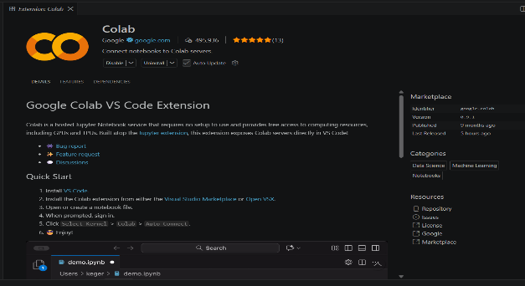
Python | Data processing, feature engineering, and model implementation. | All members
Microsoft Team | Team communication and quick coordination outside workshops. | Vidhi

Contribution register
Every member completes at least one row in their own words. Mark each task M for management (planning, client contact, minutes, scheduling, risk, document control) or T for technical (research, requirements drafting, design, prototyping, testing, tooling). Evidence must be something the tutor can open; rows without evidence do not count.

Member name | Task/activity completed this week | Type (M / T) | Evidence (link, file, commit, minutes) | Time spent (hrs)
Yaqiao Chi | Set up GitHub repository and folder structure. Led project planning activities (Activity 1-3). Created initial README and team roles. | M & T | https://github.com/Yaqiao-chi-helen/Forecasting-team4 | 2.5
Vidhi Jaydipkumar Patel | Finalised cleaning for Panama and PJM datasets. Generated initial EDA report on trends, seasonality, and missing values. | T | 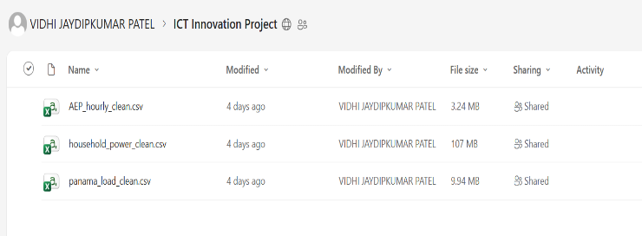 | 4.0
Bhumika Sharma | Unable to attend Week 2 and Week 3 workshops due to a medical emergency (hospitalisation). Has confirmed availability for the catch-up meeting on Thursday Aug 27 at 2:00pm to get up to speed. |  | 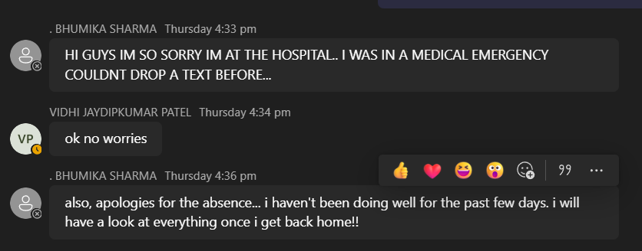 | N/A
Marwa Aldhafeeri | Reviewed Week 1-3 module on Canvas and did some research |  |  | 1-2

Agreed actions for the coming week

Owner | Action to complete before next workshop | Due date
All members | Complete reading the LSTM/XGBoost paper summary and be ready to discuss. | Next Thursday’s workshop
All members | Schedule a 30-minute meeting to share initial findings about this project | Next Thursday before the workshop
Yaqiao | Start building the baseline XGBoost model on the cleaned Panama dataset. | Next Week
Vidhi | Implement the feature engineering module (lag features, rolling means) in a Python script. | Next Week

Anything blocking the team, or any contribution imbalance the tutor should know about?

We have two main issues to report:

- Bhumika’s absence (Weeks 2-3)
Bhumika was unable to attend the Week 2 and Week 3 workshops due to personal reasons. As a result, she is currently not fully up to speed with the project’s progress and requirements. To address this, we have scheduled a short team meeting before next Thursday’s workshop to bring her up to date on everything we have covered so far: including the confirmed datasets, the chosen methodology, team roles, and next steps. We are confident this will get her back on track.

- Marwa’s low contribution
We are a bit concerned about Marwa’s level of participation in the group work so far. She contributed very little to the Week 2 and Week 3 worklogs, which has left other members to pick up the slack. We plan to have an honest conversation with her next week to clarify expectations and encourage more active involvement going forward. We hope this will resolve the issue, but wanted to flag it in case it continues.

We are committed to working through these challenges as a team and keeping the project on track.

